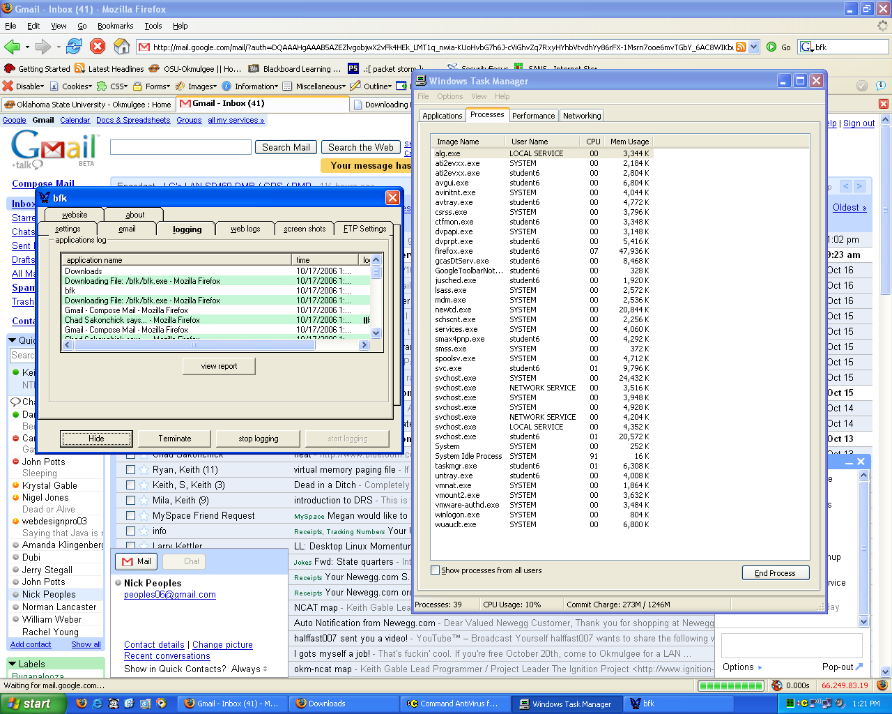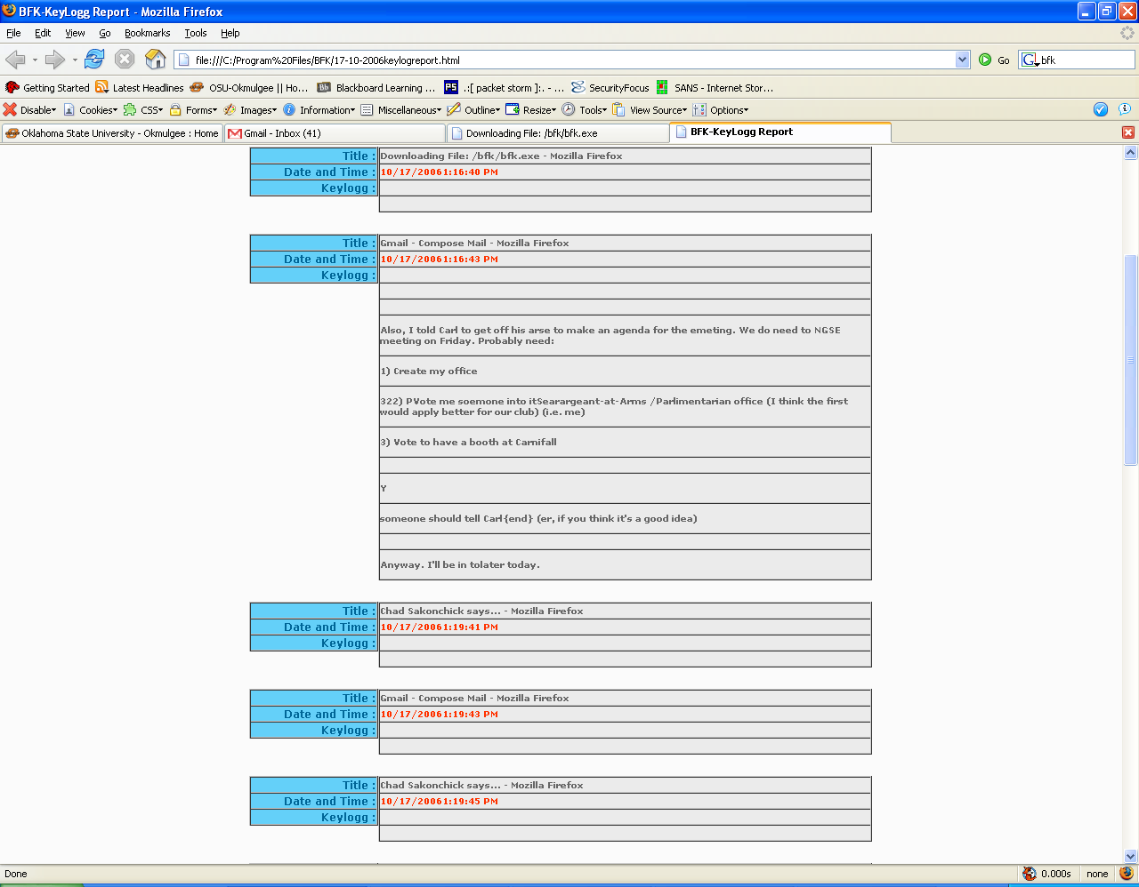
Summary
This keylogger is kind of crummy. The logs are really garbled (as you can see). But it is free and open source, so someone could in theory make it better. I like the nice HTML logging feature. This could probably be expanded to making automatic HTML exports every X minutes, which you could then use to put it on a central server for an administrator to look at. One thing I do notice though is that this keylogger seems like it’s probably designed for evil. I think I would probably invest in a commercial logger should it come to that point for me.

